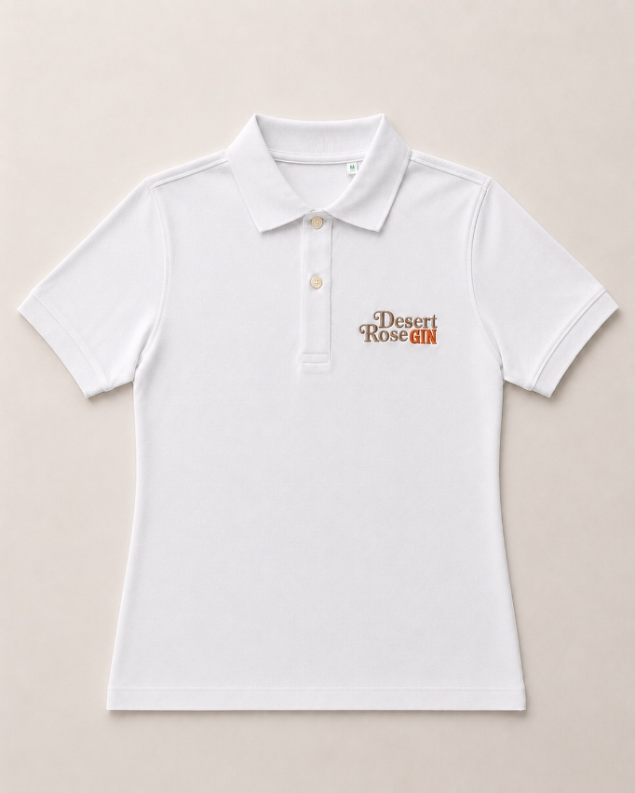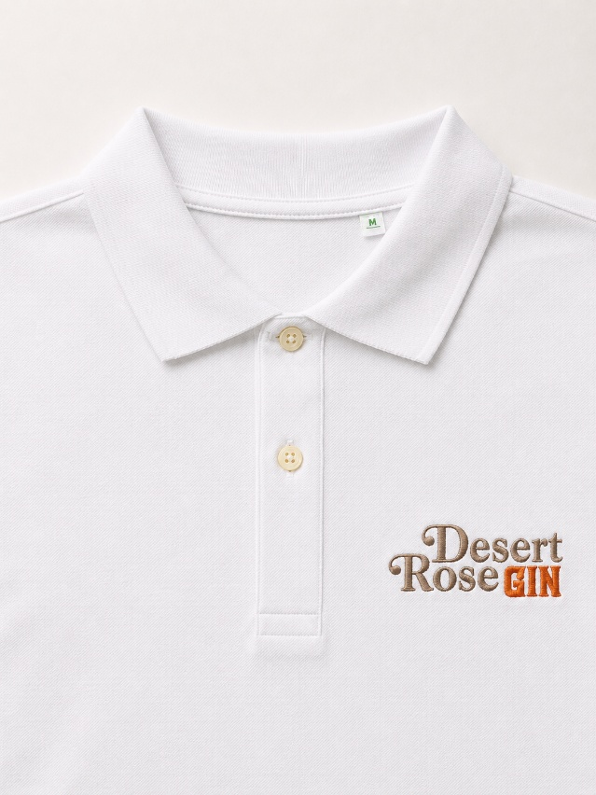
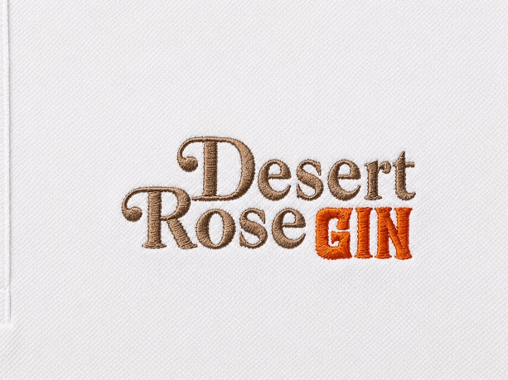
Women's Polo Shirt Desert Rose Gin – Organic Cotton
Elegant, versatile and with attention to detail, the Desert Rose Gin Women's Polo Shirt is designed for those who want a garment with a refined look without sacrificing comfort.
Made of 100% organic cotton, it offers a pleasant feeling of softness and breathability.
The slightly contoured feminine fit that flatters the silhouette without being fitted ensures an elegant and contemporary look. The classic collar with button closure and the quality finishes give the polo shirt a distinctive and professional style.
On the chest there is the embroidered Desert Rose Gin logo
Features
- 100% organic cotton
- Slightly contoured feminine fit
- Classic collar with button closure
- Soft, breathable and durable fabric
- Desert Rose Gin logo on the chest
- Color: White
- Refined finishes and professional look
Available sizes
Available in sizes:
- S
- M
- L
Garment care
- Wash at maximum 30°C
- Wash and iron inside out
- Do not use bleach
- Do not tumble dry
A polo shirt that combines sustainability, comfort and elegance, perfect for experiencing and representing the authentic spirit of Desert Rose Gin on any occasion.

